Item | Description
Project Name | Build your own plotter Machine
Age Requirement | 6th to 12th grade students (middle and high school students)
Project Code | EC.B
Abstract | Put your engineering skills to the test to see if you can build a plotter machine—powered by Raspberry Pi.
Project Cost | Registration fee: $10  Material cost:  - A Raspberry Pi (~$99) Amazon Link  - Three servo motors (~$10) Amazon Link  - Accessory kits, jumper wires and GPIO pin header to connect the Pi to the servos (~$12) Amazon Link  - Two arms  - Small items (such as a clothes-peg) depending on exactly how you build the machine.  - USB keyboard, USB Mouse and Monitor(HDMI)
Scholarship Awards | (Plotter Machine)  1st place: $150 2nd place: $100 3rd place: $50  (Creative Project)  1st place: $150 2nd place: $100 3rd place: $50
Recognition | Award recipients will be recognized at CIE’s website and eNewsletter, local news media, and showcased in CIE’s Annual Convention.
Individual or Team | Contestant(s) can register as individual or a team. Students are encouraged to form a team (max of 5 members) to participate this tournament to learn team work and to share cost & responsibility.
Schedule | Saturday 2/6/2021 – Workshop#1 – Introducing Plotter Machine Project  Sunday 2/27/2021 – Workshop#2 – Division B project working session  Saturday 3/28/2021 – 2020 SECC Competition
What to Bring on Competition Day | - Your Plotter Machine  - Send videos before deadline submit date(3/16) and present on event day  - A project document illustrating your engeering process, prepare a brief presentation or demonstration to show the Judges how your machine works.

Introduction
A BrachioGraph can be built in an hour or so without any special skills. Apart from a Raspberry Pi computer and some hobby servo motors, the plotter can be built with everyday household items such as a clothes-peg. The software in the BrachioGraph library includes code to drive the hardware and vectorise bit-map images.
BrachioGraphs benefits from contributions from the open-source community, and independently-created community resources. These include videos, brachio.me, a web version of the linedraw software used to vectorise images and 3D printed plotter components.

Materials and Equipment
Demo
1. A Raspberry Pi
2. A power supply

3. A microSD card

4. A HDMI

5. A keyboard and a mouse

6. A TV or computer screen

7. Servo motors

8. Accessory kits

9. Sticks or stiff card to make two arms, each about 10cm long (to give you 8cm arms with a centimeter to spare at each end)

10. Small items (such as a clothes-peg) depending on exactly how you build the machine.
11. Strong adhesive glue.

Your Raspberry Pi has an HDMI output port that is compatible with the HDMI port of most modern TVs and computer monitors. Many computer monitors may also have DVI or VGA ports.
Raspberry Pi 4 has two micro HDMI ports, allowing you to connect two separate monitors.
To start using your Raspberry Pi, you need a USB keyboard and a USB mouse.
To view the Raspberry Pi OS desktop environment, you need a screen, and a cable to link the screen and your Raspberry Pi. The screen can be a TV or a computer monitor. If the screen has built-in speakers, Raspberry Pi is able to use these to play sound.
There are several models of Raspberry Pi, and for most people Raspberry Pi 4 Model B is the one to choose. Raspberry Pi 4 Model B is the newest, fastest, and easiest to use.
Raspberry Pi 4 comes with 2GB, 4GB, or 8GB of RAM. For most educational purposes and hobbyist projects, and for use as a desktop computer, 2GB is enough.
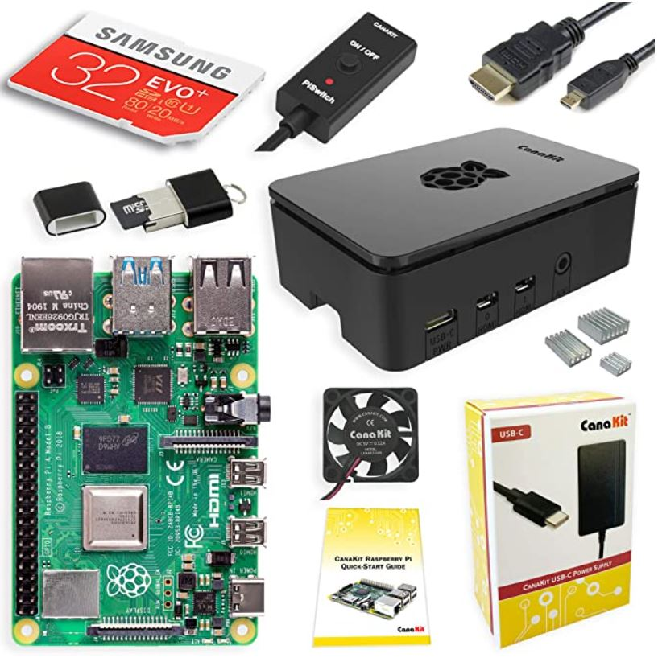

Below are some links and demos to get started:
Raspberry Pi Introduction
RaspberryPi SETUP (No audio)
RaspberryPi FINAL (No audio)
Raspberry Pi Traffic Lights

How to build the plotter
Once you have all the required materials and set up Pi environment.
Please reference below link for build instructions.
Build instructions

For software install guide, please reference to our GitHub site:
2021SECC_DivisionB_Project_Git

For questions, please reach out to ciedfw.secc@gmail.com

Project Rules
- Contestant(s) are required to upload a video (3-5 mins) to explain the project ideas and submit project engineering documents before the deadline submission date (03/16).

- For plotter machine project: three pictures’ links below will be used for the final judgements based on the drawing quality.

USA Map
The Great Wave off Kanagawa
MonaLisa

- For creative project, no limitations on what you can use to show your project.
Raspberrypi Projects Ideas

Judge Procedure

Both Plotter machine and Creative projects will be judged based on the following:

Research Question/Problem: (10 pts)

• Description of a practical need or problem to be solved

• Definition of criteria for proposed solution

• Explanation of constraints

Design and Methodology: (15 pts)

• Exploration of alternatives to answer need or problem

• Identification of a solution

• Development of a prototype/model

Execution: Construction and Testing: (20 pts)

• Prototype demonstrates intended design

• Prototype has been tested in multiple conditions/trials

• Prototype demonstrates engineering skill

• Prototype demonstrates completeness

Creativity: (20 pts)

• The questions asked are student-initiated and original

• The approach to solving the problem is creative

• Equipment is creatively used or had to be made/modified

• Interpretation of the data shows creative and original thinking by student

Presentation Document/Poster: (10 pts)

• Logical organization of material

• Clarity of graphics and legend

• Supporting documentation displayed

Presentation - Interview: (25 pts)

• Clear, concise, thoughtful responses to questions

• Understanding of basic science relevant to project

• Degree of independence in conducting project (Note: if team project, contributions to and understanding of project by all members)

• Recognition of potential impact in science and/or society

• Quality of ideas for further research

